**Activity 2: Creating an Ntier Architecture using CF Template**

* Now lets create public route table
* associate with web1, web2 subnets
* Add a route to internet gateway
* Now lets add private route table
* associate with db1, db2 subnets  
  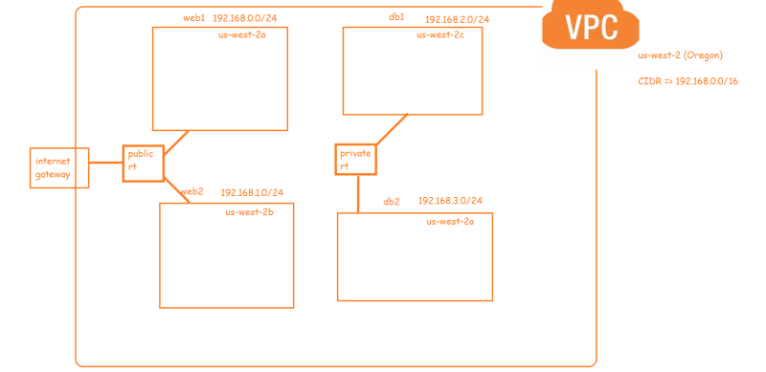
* <https://docs.aws.amazon.com/AWSCloudFormation/latest/UserGuide/aws-resource-ec2-routetable.html> for the route table docs
* <https://github.com/asquarezone/awsadministration/commit/5452df134ccd02a91021032930087613551ea634> for the changes done and execute the template to create the stack  
  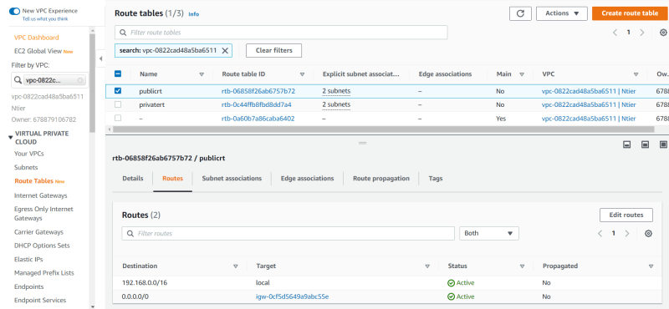  
  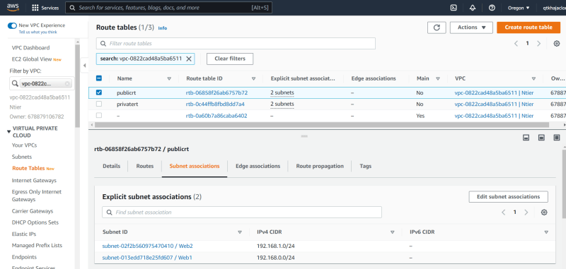  
  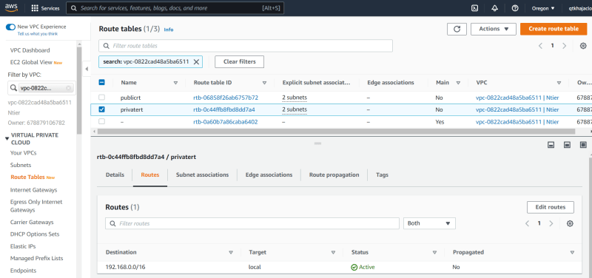  
  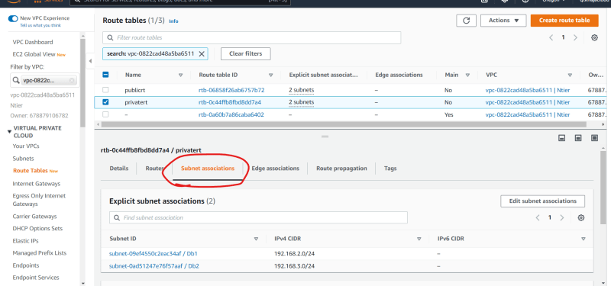
* Now lets create a security group for virtual machines (ec2 instances) in web subnet
* open port 80 for all
* open port 22 for all
* open port 443 for all
* Execute the template <https://github.com/asquarezone/awsadministration/commit/f416e86e14753994245a05429e3522092e3f84cd> for the changes by updating the stack  
  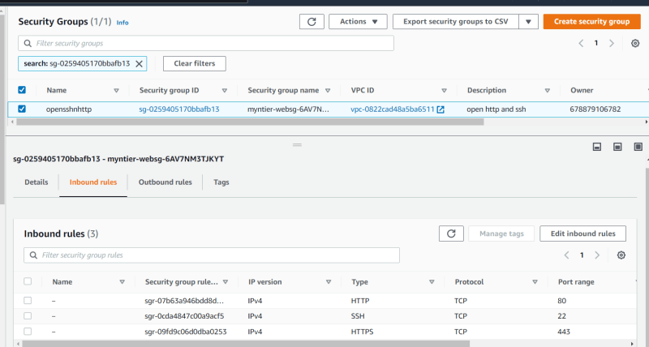
* Now lets add a security group for mysql database which should open 3306 port to all the vpc range <https://github.com/asquarezone/awsadministration/commit/0766533efc133171df117050ab439b17c137d432> for the changes done  
  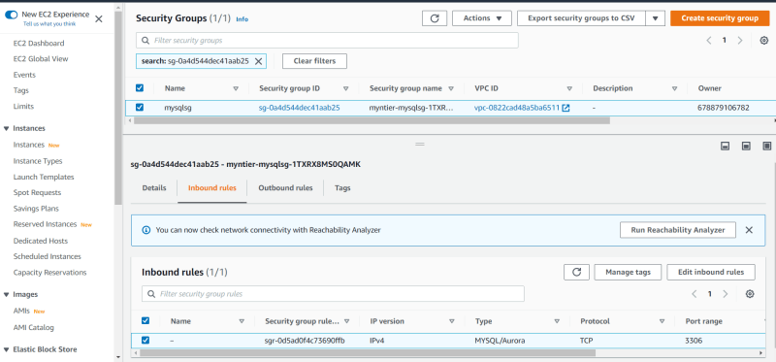
* Exercise: We need to create a Db subnet group with atleast two subnets in it. Try adding a resource in the existing template to do the following  
  